TAHA MUZAMMIL RASOOL
CMS:456279
TASK 1
#include <iostream>
using namespace std;
int main()
{
double grade,A,B,C,D,F;
// stating marks as variable according to grades by double variable
cout<<"enter your marks please";
cin>>grade;
//user inputs grade marks
if(grade>=90 and grade<=100){
cout<<"A grade";
}
else if(grade>=75 and grade<=89){
cout<<"B grade";
}
else if(grade>=60 and grade<=74){
cout<<"C grade";
}
else if(grade>=45 and grade<=59){
cout<<"D grade";
}
else if(grade>=45 and grade<=0){
cout<<"F grade";
}
else{
cout<<"please enter marks between 0-100";
}
//putting ranges for different grade levels

}
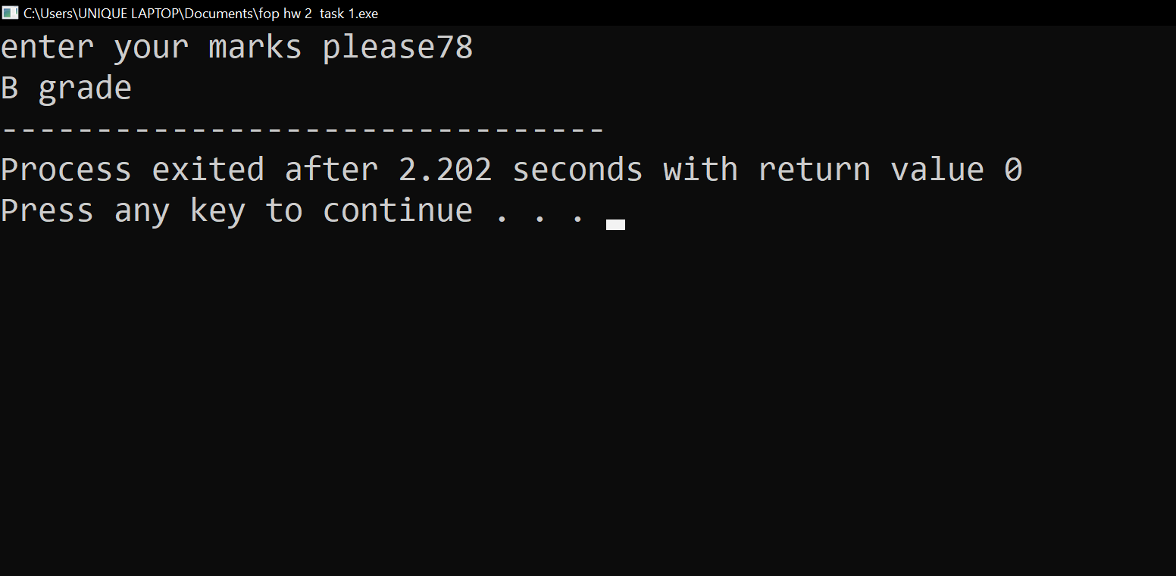

TASK 2
#include <iostream>
#include<cmath>
using namespace std;
int main()
{
int integer, count;
for (count=1; count <=100; count=count+1)
{
cout<<"enter the integer\n";
cin>>integer;
if (integer%10==0)
{
cout<<"integer is even and divisible by 5\n";
}
else if (integer%5!=0 && integer%2!=0)
{
cout<<"integer is neither even nor divisible by 5\n";
}
else if (integer%5 !=0 && integer%2==0)
{
cout<<"integer is even but not divisible by 5\n";
}
else if (integer%5==0 && integer%2!=0)
{
cout<<"integer is not even but divisible by 5\n";
}
return 0;
}
}
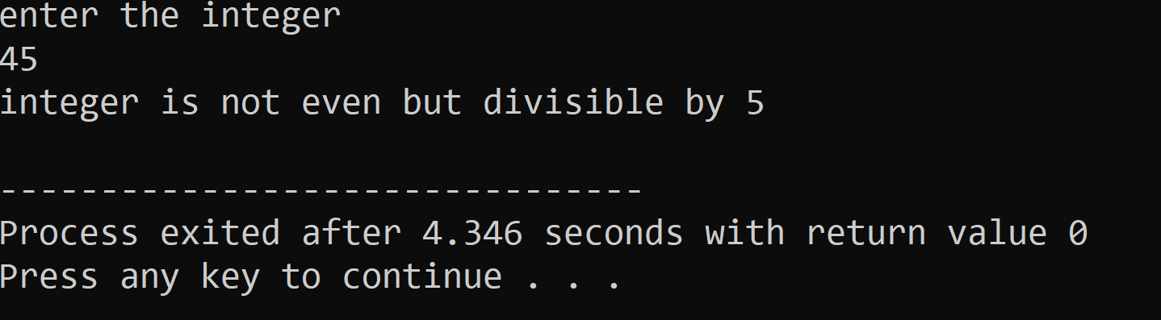

TASK 3
#include <iostream>
using namespace std;
int main()
{
int year;//assigning data type
cout<<"enter year";
cin>>year;
if(year%400==0||year%4==0){
cout<<year<<" is a leap year";
}
else {
cout<<year<<" is not a leap year";
}
}

TASK 4
#include <iostream>
using namespace std;
int main()
{
double gpa,attendance;// assigning data type
cout<<"enter your GPA";
cin>>gpa;// taking gpa
cout<<"enter your attendance";
cin>>attendance;// taking attendance
if(gpa>=3.5&&gpa<=4&&attendance>=80&&attendance<=100){// setting required limits
cout<<"congratulations you are eligible for scholarship";
}
else if(gpa<0||gpa>4||attendance<0||attendance>100){// if the limits are crossed
cout<<"please enter details correctly";
}
else{
cout<<"you are not eligible for scholarship ";// otherwise
}
}
